1.

Given that A = {1, 2, 3, 4, 5, 6} and B = {3, 6, 9, 12}, find A ∪ B.
A.
{3, 6}
B.
{6, 12}
C.
{2, 3, 4, 5, 9, 12}
D.
{1, 2, 3, 4, 5, 6, 9, 12}

2.

Write 2340000 in standard form.
A.
2.34 x 10⁻⁶
B.
2.34 x 10⁻⁵
C.
2.34 x 10⁶
D.
2.34 x 10⁷

3.

How many faces has a cuboid?
A.
12
B.
8
C.
6
D.
4

4.

Subtract 125.47 from 203.90
A.
78.57
B.
78.43
C.
-121.57
D.
-122.38

5.

Simplify (5m + 3n)-(2m-n).
A.
5m - 4n
B.
3m + 4n
C.
3m - 2n
D.
7m + 4n

6.

Which of the following sets is equal to {1, 2, 3, 4}?
A.
{2, 4, 1, 5}
B.
{2, 1, 4, 3}
C.
{1, 2, 3, 4, ...}
D.
{2, 3, 4, 5, ...}

7.

In a town of 42,800 inhabitants, 48% are male. The rest are female. How many more females are there than males?
A.
22,256
B.
20,544
C.
1,712
D.
1,612

8.

What set does the following graph represent?
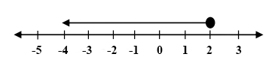
A.
{x:x < 2}
B.
{x:x ≤ 2}
C.
{x:x > 2}
D.
{x:x ≥ 2}

9.

The pie chart below shows the performance of Kate in her final examination.
Use the diagram to answer the question below.
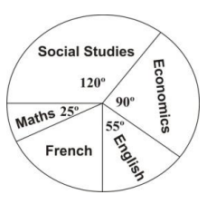
What is the angle for French?
A.
120º
B.
100º
C.
70º
D.
35º

10.

The pie chart below shows the performance of Kate in her final examination.
Use the diagram to answer the question below.
If Kate scored 60% in Social Studies, what was her score in Economics?
A.
45%
B.
54%
C.
72%
D.
90%

11.

A teacher is to be chosen at random from a group of 6 male and 2 female teachers for a patron of a Mathematics Club. What is the probability that a female teacher is chosen?
A.
3
4
B.
2
3
C.
1
3
D.
1
4

12.

Solve the equation: 2x -3(x - 1) = 6
A.
3
B.
-3
C.
-7
D.
-9

13.

If m = 3 and n = -3, evaluate
1
2
(3m - n)
A.
6
B.
3
C.
0
D.
-6

14.

Which of the following sets of angles form the interior angles of a right angled triangle?
A.
{20°, 50°, 90°}
B.
{80°, 60°, 90°}
C.
{45°, 45°, 90°}
D.
{65°, 90°, 35°}

15.

State the rule for the mapping
x | 0 | 1 | 2 | 3 | 4
↓ | ↓ | ↓ | ↓ | ↓ | ↓
y | 0 | 1  4 | 1  2 | 3  4 | 1
A.
x →
x
4
B.
x →
x
2
C.
x →
3x
4
D.
x →
1
2x

16.

A rectangle has an area of 36 cm² and a width of 3 cm. Find its perimeter.
A.
12 cm
B.
18 cm
C.
24 cm
D.
30 cm

17.

Find the value of 4 + x⁰.
A.
3
B.
4
C.
5
D.
6

18.

A van travels 154 km in 1
3
4
hours. Find its speed in km/h.
A.
77 km/h
B.
88 km/h
C.
100 km/h
D.
269.5 km/h

19.

In the figure below, PQ and RS are straight lines. Find the value of the angle marked w°.
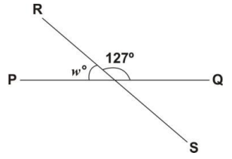
A.
27°
B.
53°
C.
63°
D.
127°

20.

If x + 5 = -7, find the value of
x
6
.
A.
-5
5
6
B.
-2
C.
-
1
3
D.
2

21.

In the following diagram, rectangle OABC is enlarged into rectangle OA₁B₁C₁ from center O. OC = 5 cm, OA = 2 cm and AA₁ = 1 cm.
Use the diagram to answer the question below.
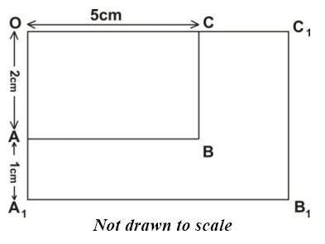
Find the scale factor of the enlargement.
A.
1
B.
1.5
C.
2
D.
2.5

22.

In the following diagram, rectangle OABC is enlarged into rectangle OA₁B₁C₁ from center O. OC = 5 cm, OA = 2 cm and AA₁ = 1 cm.
Use the diagram to answer the question below.
Calculate OC₁.
A.
7.5 cm
B.
8 cm
C.
9 cm
D.
12 cm

23.

The height of a flag pole in a scale drawing is 5 cm. If the scale is 1 cm to 3 m, what is the actual height of the pole?
A.
10 m
B.
15 m
C.
8 m
D.
5 m

24.

Factorize ax + 3x + a + 3
A.
x(a + x)
B.
(x - a)(x + 3)
C.
x(a - x)
D.
(a + 3)(x + 1)

25.

If y =
x + 8
x - 4
, find the value of y when x = 2.
A.
5
B.
-5
C.
4
D.
-4

26.

Find the Greatest Common Factor (GCF) of 90, 126 and 72.
A.
6
B.
9
C.
18
D.
24

27.

Given that 1 : 3 = x : 21, find the value of x.
A.
4
B.
5
C.
7
D.
63

28.

Find the difference between 432_{five} and 143_{five}
A.
234_{five}
B.
334_{five}
C.
1130_{five}
D.
1310_{five}

29.

Simplify: 14
1
3
- 2
3
8
+ 5
7
12
A.
6
3
8
B.
7
5
12
C.
17
5
12
D.
17
13
24

30.

Nine bottles of equal capacity hold 4
1
2
litres of water. How much do x bottles hold?
A.
1
2
x litres
B.
2x litres
C.
20
1
2
x litres
D.
40
1
2
x litres

31.

A sales girl receives a 5 % commission on all she sells. Find how much she has to sell to receive GH₵ 15.00.
A.
GH₵ 750.00
B.
GH₵ 300.00
C.
GH₵ 75.00
D.
GH₵ 30.00

32.

Arrangle the following fractions in ascending order:
7
12
,
3
5
,
7
15
,
3
4
A.
3
5
,
7
15
,
7
12
,
3
4
B.
7
12
,
7
15
,
3
5
,
3
4
C.
7
15
,
7
12
,
3
5
,
3
4
D.
3
5
,
3
4
,
7
12
,
7
15

33.

Add 2.5 to the product of 4.2 and 0.2
A.
13.4
B.
10.9
C.
3.34
D.
1.34

34.

What is the value of four in the number 7073.48?
A.
four tenth
B.
four
C.
forty
D.
four hundred

35.

The table below shows the ages of children at a birthday party.
Ages(years) | No. of Children
1 | 3
2 | 4
3 | 2
4 | 5
5 | 4
6 | 4
7 | 6
8 | 4
9 | 2
10 | 1
Use this table to answer the question below.
What is the modal age?
A.
10
B.
7
C.
5
D.
4

36.

The table below shows the ages of children at a birthday party.
Ages(years) | No. of Children
1 | 3
2 | 4
3 | 2
4 | 5
5 | 4
6 | 4
7 | 6
8 | 4
9 | 2
10 | 1
Use this table to answer the question below.
A child is selected at random, what is the probability that he or she is 4 years old?
A.
4
35
B.
1
7
C.
2
5
D.
4
5

37.

The table below shows the ages of children at a birthday party.
Ages(years) | No. of Children
1 | 3
2 | 4
3 | 2
4 | 5
5 | 4
6 | 4
7 | 6
8 | 4
9 | 2
10 | 1
Use this table to answer the question below.
How many children are 7 or more years old?
A.
28
B.
22
C.
13
D.
6

38.

Write the vector
(
6 cm W
4 cm S
)
using cartesian components.
A.
(
-6
-4
)
B.
(
-4
-6
)
C.
(
-6
4
)
D.
(
6
-4
)

39.

Simplify: 5 - 7 + 2(3 - 8)
A.
-12
B.
-8
C.
-5
D.
-4

40.

If r =
(
-10
-3
)
and n =
(
8
-6
)
, find n + r.
A.
(
-2
-9
)
B.
(
2
-9
)
C.
(
18
9
)
D.
(
-2
-3
)

